# Laboratory 1

Table of Contents

Laboratory 1 1

Git hub : https://github.com/sajevk/Computational-Social-Network-Analysis 1

Running Network X and Python 1

Computations using Network X 2

Qualitative Nature of Networks 2

Directed Networks 2

Plot Degree Distribution 3

Undirected Graph – Facebook – Node Analysis 4

Power Law - Degree Distribution 7

Kronecker Product Graph 10

## **Git hub :** <https://github.com/sajevk/Computational-Social-Network-Analysis>

## **Running Network X and Python**

* Downloaded the Facebook Combined.txt in order to perform Computational Analysis.
* Using Network-X the Degree Distribution, Assortativity Coefficient and Clustering Coefficient for the Facebook Combined.txt networks.
* Installed Network X and Python and got started with the Assignment. Downloaded the Facebook_combined.txt to analyse the computational network theories.
* The dataset consists of 'circles' (or 'friends lists') from Facebook. Facebook data was collected from survey participants using this [Facebook app](https://www.facebook.com/apps/application.php?id=201704403232744). The dataset includes node features (profiles), circles, and ego networks.
* The code base has been checked into the Git Hub /

## Computations using Network X

* (**'Degree Assortative Coefficient** = ', -0.042046405552291777)
* (**'Neighbour Degree** = **Copying only small subset to this document to avoid copying the long list of the neighbouring degrees)** , {0: 10.70028818443804, 1: 11.3125, 2: 5.333333333333333, 3: 26.4375, 4: 3.4444444444444446, 5: 11.583333333333334, 6: 2.4, 7: 13.31578947368421, 8: 1.7142857142857142, 9: 17.072727272727274, 10: 17.11111111111111, 11: 0.0, 12: 0.0, 13: 22.4, 14: 6.5, 15: 0.0, 16: 12.25, 17: 7.583333333333333, 18: 0.0, 19: 4.142857142857143, 20: 5.5, 21: 17.822580645161292, 22: 7.333333333333333, 23: 3.0625, 24: 10.4, 25: 14.430769230769231, 26: 15.951612903225806, 27: 12.0, 28: 6.0, 29: 17.09090909090909, 30: 15.4, 31: 14.0, 32: 3.6, 33: 0.0, 34: 116.0, 35: 6.0, 36: 5.7, 37: 0.0, 38: 5.857142857142857, 39:
* **('Average cluster:'**, 0.6055467186200871)
* **('Average clustering:',** 0.6055467186200871)

## Qualitative Nature of Networks

### Directed Networks

**The qualitative nature of the graph was analysed for the Directed Graph of Amazon.**

**Sketched the broader et al picture of the network. The number of the nodes in the strongest connected component and the In and Out of the sections were analysed.**

**Here are the attribute values for the Directed Graph**

* Loading amazon graph
* ('Graph nodes: ', 262111)
* ('Graph edges: ', 1234877)
* ('Strongly Connected Component Count - ', 6594)
* ('Biggest connected component size: ', 241761)
* ('In degree - ', 0)
* ('Outdegree = ', 4541)

### Plot Degree Distribution

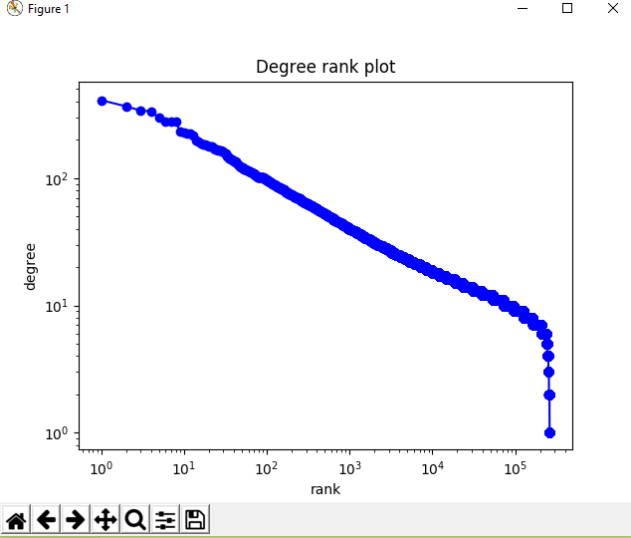

### **Undirected Graph – Facebook – Node Analysis**

The undirected graph for Facebook was analysed and the sparse matrix along with the strongly connected nodes, in-degree and out-degree was analysed. Please find below.

* Loading Facebook graph
* ('Graph nodes: ', 4039)
* ('Graph edges: ', 88234)
* ('Strongly Connected Component Count - ', 4039)
* ('Biggest connected component size: ', 1)
* ('In degree - ', 2)
* ('Outdegree = ', 376)

**Sparse Matrix**

The Facebook combined sparse matrix was generated as below :

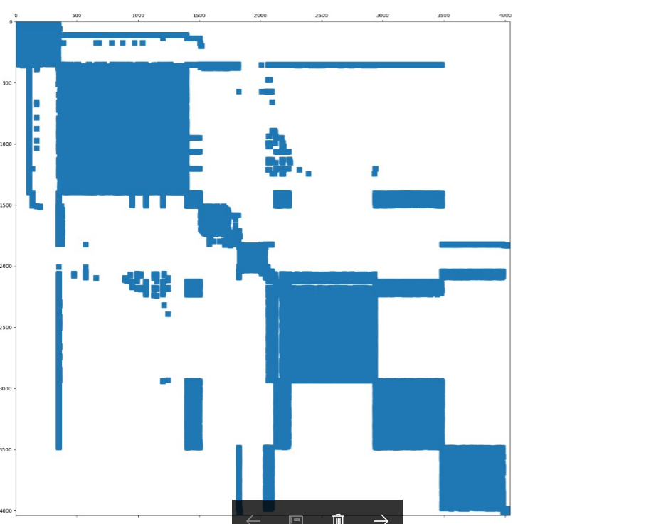

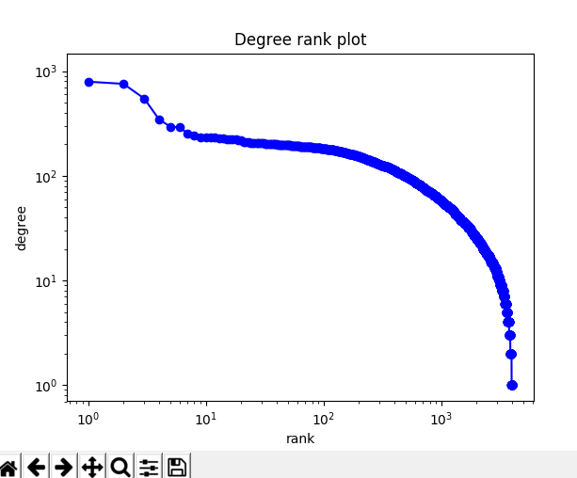

### **Power Law - Degree Distribution**

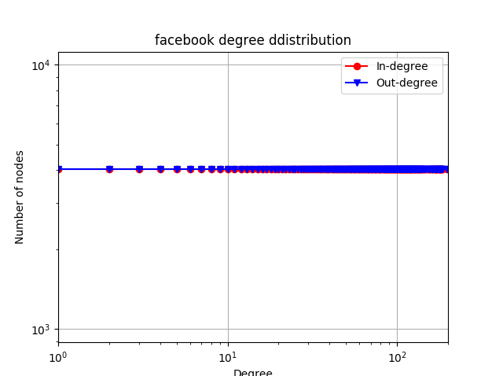

**Price Model**

* **The below price model was generated for citation count of 25.**
* **It is** a mathematical model for the growth of the citation network. Please find **below the edges of the nodes generated for the citation graph. The number of nodes is specified to be 500.**

**1**

**2**

**…… (lines deleted to reduce page numbers)**

**….… (lines deleted to reduce page numbers)**

**… (lines deleted to reduce page numbers)**

**…**

**497**

**498**

**499**

**(1, 0)**

**(2, 0)**

**(2, 1)**

**(3, 0)**

**… (lines deleted to reduce page numbers)**

**… … (lines deleted to reduce page numbers)**

**… (lines deleted to reduce page numbers)**

**…**

**(496, 5)**

**(497, 3)**

**(497, 4)**

**(497, 5)**

**(497, 206)**

**(497, 191)**

**(498, 2)**

**(498, 3)**

**(498, 4)**

**(498, 5)**

**(498, 108)**

**(498, 396)**

**(498, 79)**

**(498, 188)**

**(499, 2)**

**(499, 3)**

**(499, 4)**

**(499, 5)**

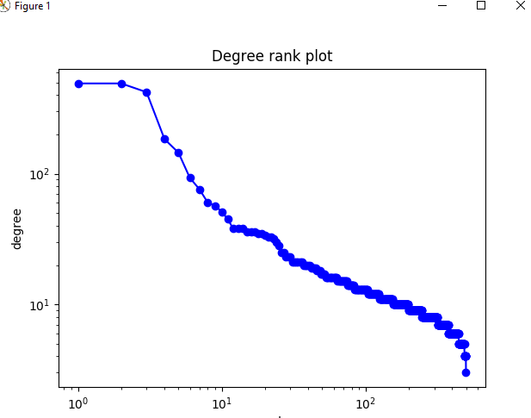

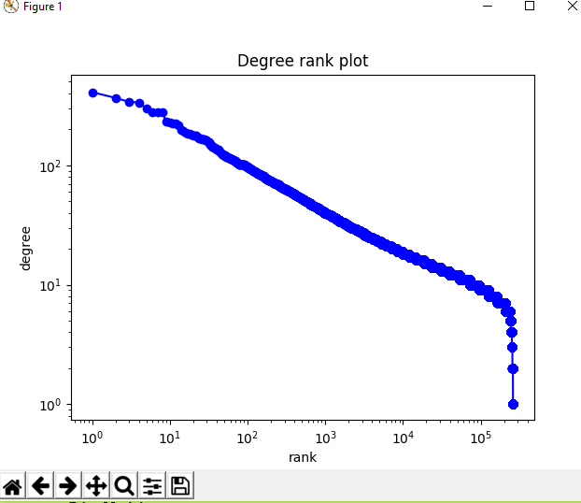

### Kronecker Product Graph

 The algorithm constructed a sequence of graphs from a small base graph by iterating the Kronecker product. Please find below the number of nodes and edges generated and the graph.

('Nodes: ', 6)

('Edges: ', 18)

